Grand Plaza Mövenpick Media City announces free entry authentic Munich-style Oktoberfest M’City beginning October 23, 2019.

Press Release

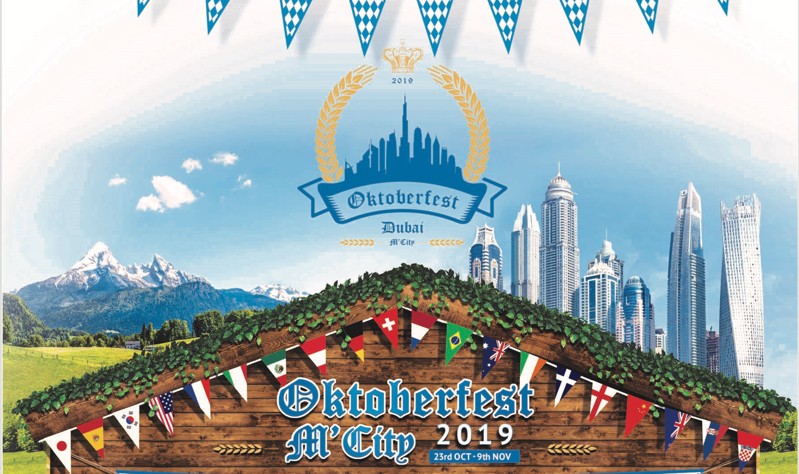

Dubai, UAE, September 23, 2019 – From October 23 to November 9, Dubai Media City will witness the first authentic Bavarian Festival – where Oktoberfest fans, families and experience-seekers will have 18 days to enjoy one of the most awaited folk festivals with the traditional Munich-style Oktoberfest Tent. Conveniently located on Sheikh Zayed Road and with easy access via EXIT 34, Oktoberfest M’City promises an authentic experience amidst traditional chalet-style tent, Bavarian food, music and, entertainment.

Throughout the Festival, Oktoberfest M’City will host a series of exclusive deals and exciting entertainment, including ‘Munich Muscles’ games for men on Mondays, where strong competitors will test their manhood. Moreover, exclusive Damen Wiesn - ladies’ night will take place every Tuesday – where ladies will enjoy chalet-style tent only for their selves from 5 – 8 pm. Daily happy HB hours, a unique Oktoberfest souk and a Latin inspired Oktoberfest Party “Caipi-Party” are not to be missed. Additionally, fun is expected at the Big Bavarian Brunch every Friday, featuring an array of Bavarian specialties in buffet style and a Saturday Family Brunch with a live band, competitions and fun activities, priced from AED 179; and much more. Also, the tent is available on selected dates for exclusive corporate events.

Visitors will discover the Grand Plaza Mövenpick Media City transformed into a mini Bavaria, complete with an authentic chalet style tent that can host up to 500 guests, wooden Hofbraeuhaus tables and benches shipped from Munich, and traditional ‘O’zapft is’ tapping of the first keg by H.E. Holger Mahnicke, Consul General of the Federal Republic of Germany in Dubai.

The Festival is traditionally German, an authentic Bavarian menu curated by Chef Alfred Zuberbuehler’s including the likes of cold traditional Bavarian appetizers and sausages, Bavarian Bratwurst and roasted knuckle, freshly baked pretzels, German apple strudel and, Mövenpick Ice cream. As well as authentic Bavarian food, guests are served traditional beverages exclusively crafted by Munich breweries for the Oktoberfest. There is also a selection of German wines and a variety of mixed drinks including Aperol Spritz and Caipirinha, in addition to soft drinks and fresh juices.

Even the music is genuinely German, with the 5-member Oktoberfest band ‘Gaudiblosn’ - flying in directly from Munich and playing every day, just for Oktoberfest M’City. From rock to traditional folk and popular Oktoberfest hits, the band recreates the atmosphere from their Bavarian homeland. Visitors will be able to take an authentic piece of our unforgettable Festival from an array of traditional Oktoberfest souvenirs including Bavarian felt hearts and classic steins.

At this authentic German Festival, there’s plenty of fun for the little ones, especially during our Saturday Family Brunch including an exclusive kids’ zone with reading area, cooking classes, hair making activities, and dances. In support of the German love for football, UHD screens will be broadcasting live football games.
Oktoberfest M’City is a real family and authentic affair - organized by a dedicated and passionate team lead by a German national, Felix Hartmann. The property’s Executive Assistant Manager, Felix Hartmann shares: “We are delighted to soon host the first authentic Bavarian celebration in Dubai Media City. Oktoberfest M’City’s authenticity, central location, and exciting program will bring the best experiences for families, guests, and Oktoberfest fans. Every element of the event has been carefully designed in line with the traditional Munich-style Festival”.
For a memorable experience full of food, culture and, traditions, mark your calendar now and make your way to Oktoberfest M’City to embrace your inner German!

Fact Box:

Where: Grand Plaza Mövenpick Media City
When: October 23 – November 9, 2019
Time: Daily, from 5 pm to 2 am
Program: Full event program will be available at movenpick.com/grand-plaza from late September
Tickets: FREE entry
Social: Facebook and Instagram @gpmovenpick
Hashtags: #OFestMCity #myGPmoments
Media kit: https://www.dropbox.com/sh/jqc6k69310ee0yk/AABU6EJJxnTXtSiDsWk546J6a?dl=0

For more information visit www.movenpick.com/grand-plaza and for reservations or enquires please call at +971 54 793 1426, or email Ofest@movenpick.com

– Ends –

About Grand Plaza Mövenpick Media City

Grand Plaza Mövenpick Media City prides itself in its story – doing ordinary things in an extraordinary way. Located in the heart of Dubai Media & Internet City – a vibrant business district – and a walk away from the emblematic Palm Jumeirah and Dubai Marina District, the 5-Star property is ideal for business and leisure travellers seeking to realize opportunity. Inspired by the Middle-Easter culture, Grand Plaza Mövenpick Media City boasts 235 sophisticated and spacious rooms and suites, offering breath-taking views of the Palm Jumeirah and Emirates Golf Club.

The property features elegant and spacious rooms and suites with a minimum of 46 sqm as well as a state-of-the-art Convention Centre with nine Flexible Meeting Rooms and 600 sqm Ballroom.

Grand Plaza Mövenpick Media City offers a large diversity of international cuisines & entertainment across five intimate restaurants, lounges, & bars. Guests can experience Grand Delicacies under the majestic hand-blown glass chandelier at the Grand Lounge, live cooking stations at Slice - The Neighborhood Deli, a modern European influenced cuisine at Verve – Bar & Brasserie, a healthy and refreshing menu by the pool or aperitif at Bytes and an affordable upmarket chic experience at TWENTY THREE Rooftop Bar.

Grand Plaza Mövenpick Media City champions moments of opportunity, inviting guests to turn their what if’s into why not and make the most of now.

For further information, please contact:

Maria Portilla Irastorza | Marketing and Communications Manager | Grand Plaza Mövenpick Media City
Phone +971 54 793 1402 | maria.irastorza@movenpick.com

