Movenpick Hotel Ibn Battuta Gate’s Shanghai Chic flaunts “Reunion” menu for Chinese New Year

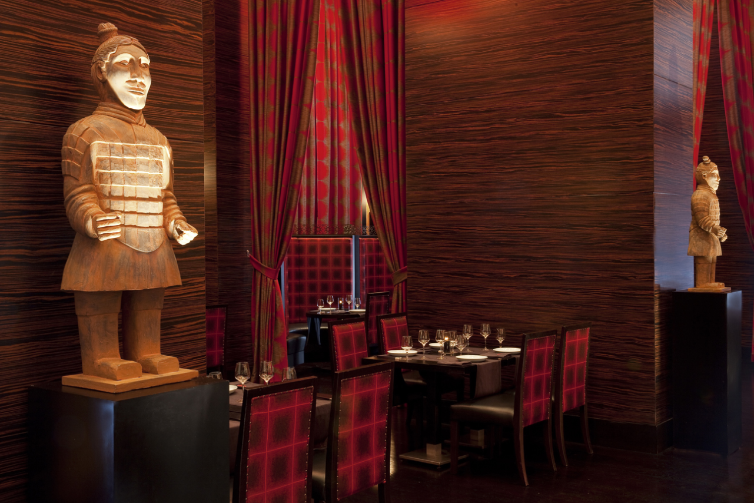

The Asian restaurant is serving a generous set menu from AED 188.

Dubai, UAE – Movenpick Hotel Ibn Battuta Gate’s signature Asian restaurant, Shanghai Chic, welcomes the Chinese New Year with an abundant set menu available only for a limited period.

- “Reunion” set menu is available from January 23 to February 22
- AED 188 per person inclusive of soft beverages
- AED 288 per person inclusive of house beverages
- Shanghai Chic is open daily from 6:30pm to 11pm
- Free valet is available when dining at the restaurant

Centred on reuniting family and friends, guests are bound to enjoy an exquisite array of items such as lobster dumpling with green asparagus, reunion crispy rice lobster soup, squirrel shaped seabass fish with Chinese sweet vinegar sauce, premium beef rib eye with black pepper sauce, and wok-fried seasonal vegetables with crystal shrimps and gingko nuts.

Speaking about the celebrations, Nachwan Koukach, Executive Chef, Movenpick Hotel Ibn Battuta Gate Dubai said, “Chinese New Year is greatly celebrated at Shanghai Chic with this year focused on the true essence of the festivities -- the reunion with loved ones. The menu features traditional items that kindle memories of the past while celebrating the start of another prosperous Lunar year”.

Coinciding with the celebrations, brunch-goers for the award-winning Friday Family Brunch at Al Bahou on January 24 will be entertained with a special lion dance performance to welcome the Chinese New Year. Brunch packages start from AED 325 per person inclusive of soft beverages.

Make your reservations now by calling: 04 444 5613 or through social @MovenpickIBG

--ends--

About Mövenpick Hotel Ibn Battuta Gate
Discover vibrant Dubai and immerse yourself in the authentic Arabian style of Mövenpick Hotel Ibn Battuta Gate Dubai. The luxury hotel is walking distance from Ibn Battuta Shopping Mall and the Dubai Metro, with easy access to Dubai’s top attractions. The Palm Jumeirah, Dubai Marina and Jebel Ali Free Zone are nearby. The 14th century travels of the Arab explorer Ibn Battuta have inspired our 396 rooms and suites, with intricate design details and cuisines from China, India, Arabia and the Mediterranean through its eight restaurants, bars and lounges. Unwind at our rooftop swimming pool, stay fit in the gym or enjoy a treatment at the spa. Take advantage of complimentary beach access and transfers to Private Beach Club on The Palm Jumeirah and get the children to explore some fun activities at the Little Birds Club. Host an unforgettable Dubai conference or event in our ballroom, 15 meeting rooms, outdoor venues or magnificent grand hall with its 88 giant lanterns.

For further information, please contact:
Angelo De Guzman
Marketing and Communications Manager
Mövenpick Hotel Ibn Battuta Gate Dubai
Phone: +971 4 4440000 | Mobile: +971 56 9434 775 / +971 55 400 2759
angelo.deguzman@movenpick.com | www.movenpick.com

