An overload of meats and prime cuts arrives every Wednesday at Mistral Restaurant

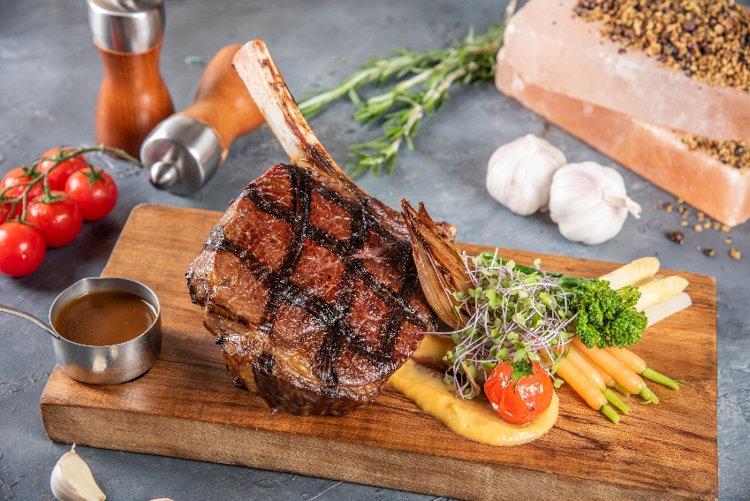

Mövenpick Hotel Ibn Battuta Gate introduces the all-new Butcher’s Night buffet from AED 210

Dubai, UAE – Taking place at Mistral Restaurant from 6.30pm–11pm, the all-day dining restaurant is serving a protein-packed buffet of unlimited choices of prime cuts cooked the way you want.

An experience on its own, diners can handpick and select from an overwhelming array of fresh high-quality meats that the chefs will cook on the spot.

“Our brilliant Butcher’s Night offer brings more than four hours of endless tender cuts and quality steaks prepared to your heart’s content. For a packed meal mid-week, we have carefully selected the meats to be added on the menu to complement each other while we cook it fresh, live, and just the way you like it,” said Executive Chef Nachwan Koukach.

Match your meaty mains with a selection of salads, cold cuts, cheeses, and more but make sure to leave room for dessert especially for its signature Mövenpick ice cream.

Packages start from AED 210 with soft beverages and AED 315 with house beverages per person.

For reservations call +971 4 444 5613 or e-mail dine.ibnbattuta@movenpick.com.

@MovenpickIBG

About Mövenpick Hotel Ibn Battuta Gate
Discover vibrant Dubai and immerse yourself in the authentic Arabian style of Mövenpick Hotel Ibn Battuta Gate Dubai. The luxury hotel is walking distance from Ibn Battuta Shopping Mall and the Dubai Metro, with easy access to Dubai’s top attractions. The Palm Jumeirah, Dubai Marina and Jebel Ali Free Zone are nearby. The 14th century travels of the Arab explorer Ibn Battuta have inspired our 396 rooms and suites, with intricate design details and cuisines from China, India, Arabia and the Mediterranean through its eight restaurants, bars and lounges. Unwind at our rooftop swimming pool, stay fit in the gym or enjoy a treatment at the spa. Take advantage of complimentary beach access and transfers to Private Beach Club on The Palm Jumeirah and get the children to explore some fun activities at the Little Birds Club. Host an unforgettable Dubai conference or event in our ballroom, 15 meeting rooms, outdoor venues or magnificent grand hall with its 88 giant lanterns.

For further information, please contact:
Angelo De Guzman
Marketing and Communications Manager
Mövenpick Hotel Ibn Battuta Gate Dubai
Phone: +971 4 4440000 | Mobile: +971 56 9434 775 / +971 55 400 2759
angelo.deguzman@movenpick.com | www.movenpick.com

