News / Appointments

Movenpick Hotel Ibn Battuta Gate Dubai appoints new Executive Chef

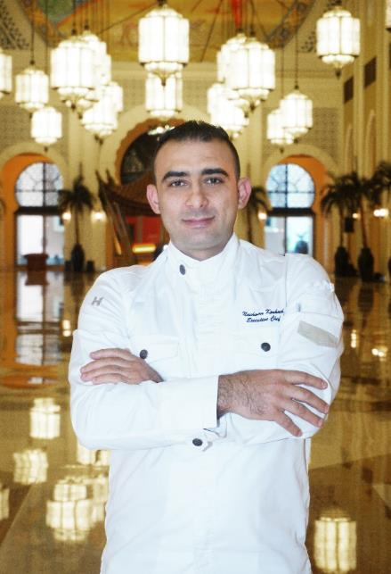

Nachwan Koukach joins the 5-star hotel and brings with him 19 years of culinary expertise

Dubai, UAE— Mövenpick Hotel Ibn Battuta Gate Dubai, one of the Top 50 hotels in the Middle East, appoints Chef Nachwan Koukach as its lead kitchen connoisseur.

The Syrian national brings with him over two decades of kitchen expertise in the Middle East and GCC region with an in-depth understanding of food philosophy and proven track record of culinary innovations.

In his role, he will oversee over 95 chefs and staff, kitchen operation of eight dining outlets, including its award-winning brunch at Al Bahou, in-room dining and banqueting. Nachwan aims at focusing on menu engineering, sustainability, and continuously incorporating Mövenpick’s world-class food and beverage prowess to cater a wide variety of discerning palates in the city.

“Movenpick Ibn Battuta Gate Dubai is a remarkable property for Food and Beverage with a wide array of dining experiences all under one roof. Dubai is such a diverse city and restaurants should always keep up to the ever changing interests of both its residents and tourists. I am excited to join the team and bring my expertise to every dish we serve,” said Nachwan.

Commenting on the appointment, General Manager Ian Rydin said: “Nachwan is a great addition to the team as he sets sights on delivering amazing dining experiences and offerings. Compounding on to the already successful outlets, his creativity, leadership and natural flare shall continue to take the restaurant’s iconic status further.

“Nachwan’s primary task is to develop and enhance dining concepts in all of our restaurants. With Dubai Expo 2020 right around the corner, he will also take point for kitchen operations as well as outside catering events.” added Rydin.

Growing up, cooking has always been Nachwan’s passion. During his career, he won awards in the prestigious Salon Culinaire including medals in “Arabic feast set-up”, “Emirates cuisine” and “Arabic Mezzeh”. He has been leading pre-opening teams at international brands such as Four Seasons, Jumeirah, and Westin with an extensive background in handling banquets, meetings, and large events of up to 1,500 people.

# # #

About Mövenpick Hotel Ibn Battuta Gate
Discover vibrant Dubai and immerse yourself in the authentic Arabian style of Mövenpick Hotel Ibn Battuta Gate Dubai. The luxury hotel is walking distance from Ibn Battuta Shopping Mall and the Dubai Metro, with easy access to Dubai’s top attractions. The Palm Jumeirah, Dubai Marina and Jebel Ali Free Zone are nearby. The 14th century travels of the Arab explorer Ibn Battuta have inspired our 396 rooms and suites, with intricate design details and cuisines from China, India, Arabia and the Mediterranean through its eight restaurants, bars and lounges. Unwind at our rooftop swimming pool, stay fit in the gym or enjoy a treatment at the spa. Take advantage of complimentary beach access and transfers to Private Beach Club on The Palm Jumeirah and get the children to explore some fun activities at the Little Birds Club. Host an unforgettable Dubai conference or event in our ballroom, 15 meeting rooms, outdoor venues or magnificent grand hall with its 88 giant lanterns.

movenpick.com | accorhotels.com

For further information, please contact:
Angelo De Guzman
Marketing and Communications Manager
Mövenpick Hotel Ibn Battuta Gate Dubai
Phone: +971 4 4440000 | Mobile: +971 56 9434 775 / +971 55 400 2759
angelo.deguzman@movenpick.com | www.movenpick.com

