News Release

Mövenpick Hotel Ibn Battuta Gate Dubai confirms its participation at the World Travel Market London

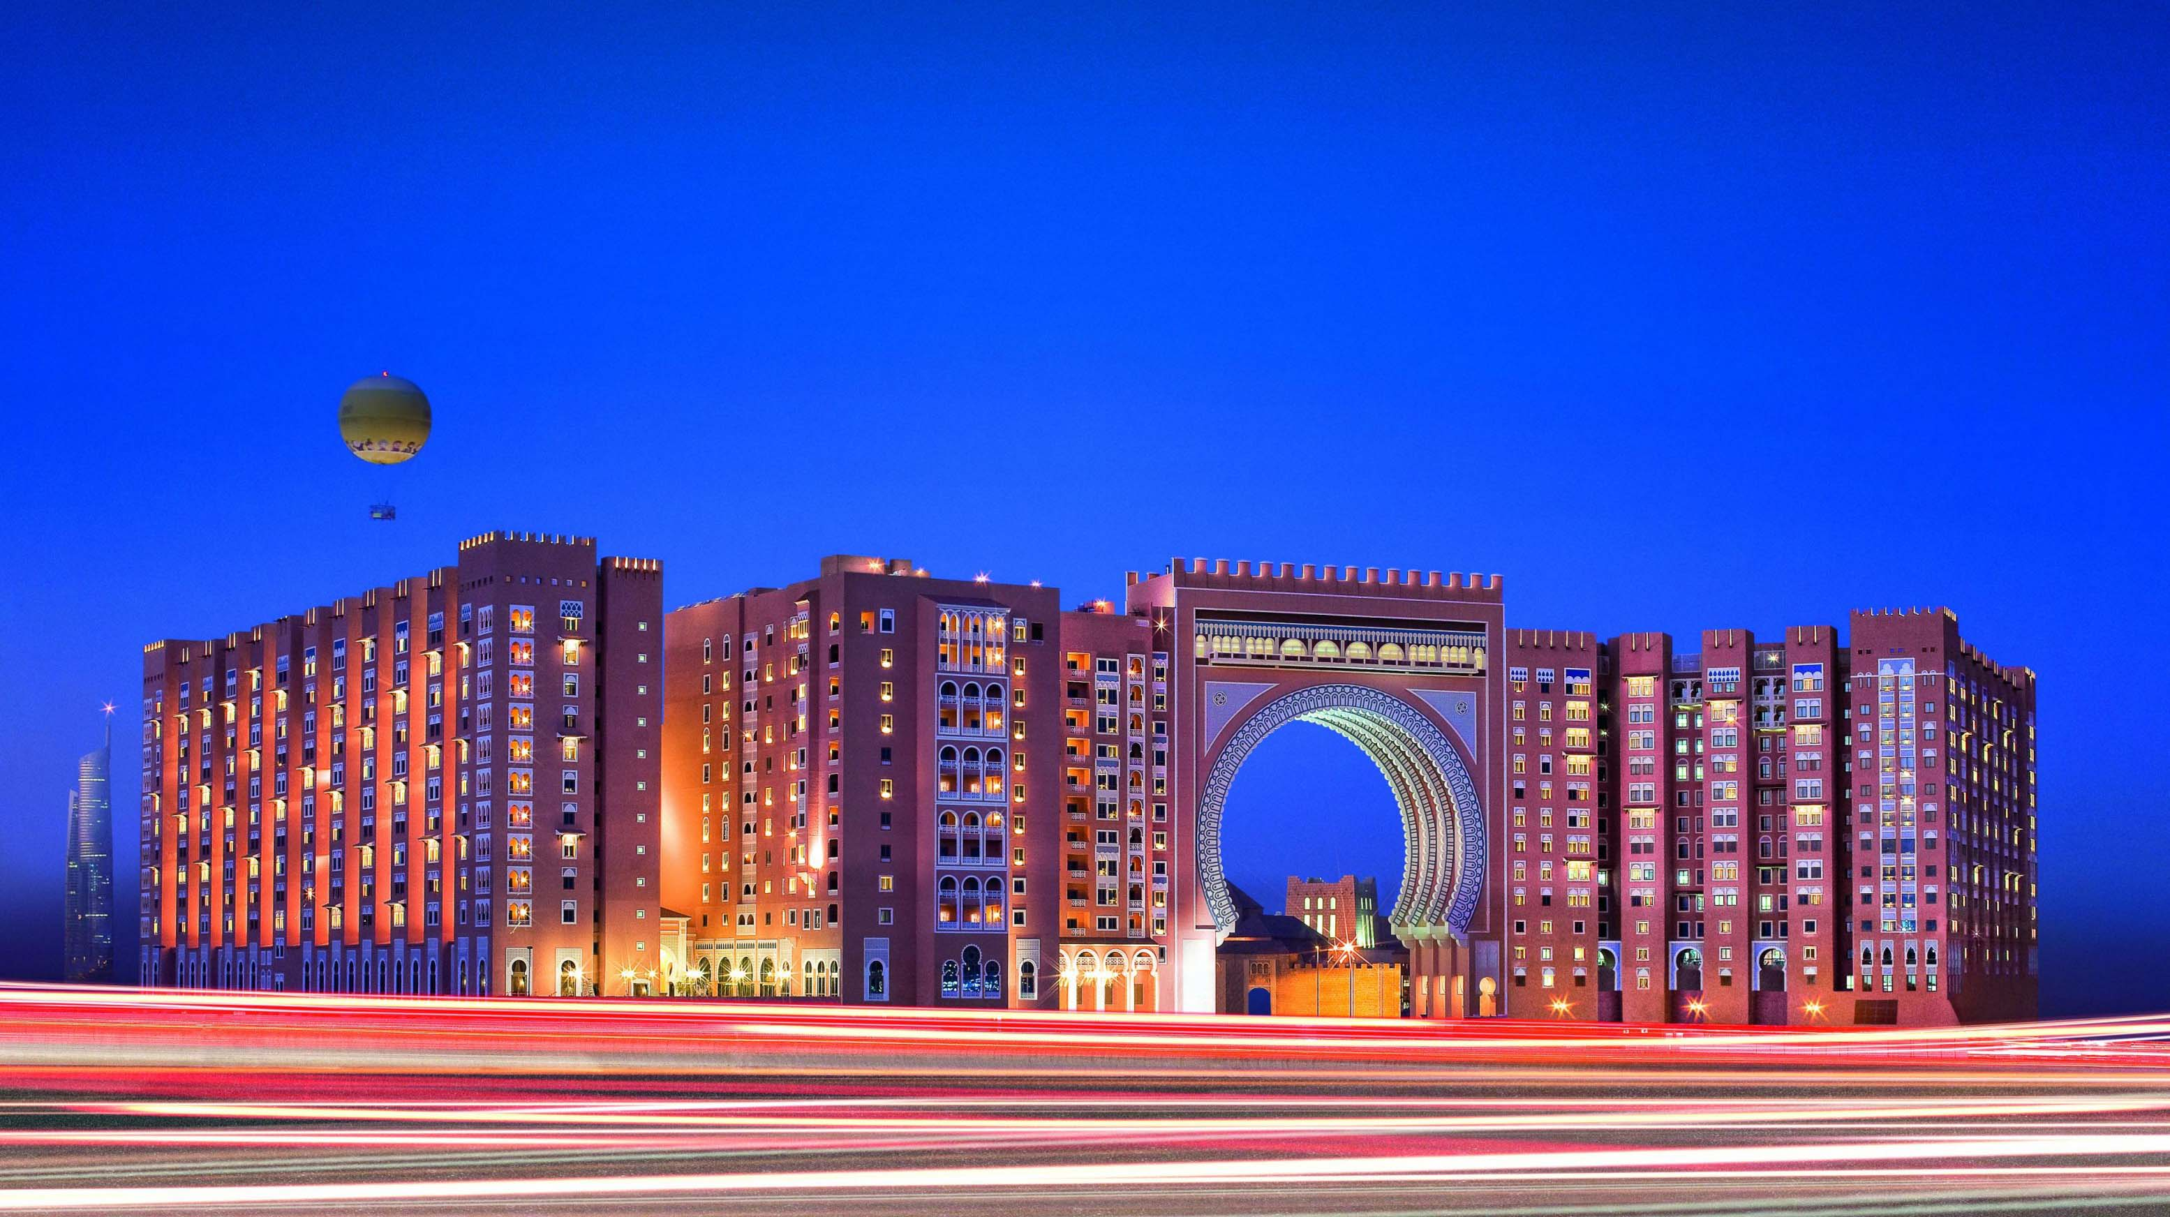

The iconic hotel joins Dubai Tourism as it promotes leisure travel and activities

Dubai, October 1, 2019: Distinctly recognized as one of the Top 50 Hotels in the Middle East, the iconic Mövenpick Hotel Ibn Battuta Gate Dubai, announces its participation in this year’s edition of World Travel Market in London from 4–6 November at stand ME300 under Dubai Tourism. The 5-star hotel aims to share travel insights, strengthen existing partnerships, and grow its connection within the industry.

“The World Travel Market London, now celebrating four decades of success, continues to be a dedicated platform for our hotel to network and reconnect with our key partners, global buyers, and distinctive travel professionals that contribute to the success of our business. Mövenpick Hotel Ibn Battuta Gate Dubai will showcase our enhanced product line-up perfect for leisure and business travellers alike. The city of Dubai has seamlessly perfected a year-round of activities from Dubai Shopping Festival, Dubai Food Festival, Ramadan/Eid Activities, GITEX and more that all lead to the much awaited Dubai Expo 2020 and beyond. This amazing city offers a multitude of unmissable experiences and activities that should be in a traveller’s destination list,” said Ian Rydin, General Manager.

Representing the hotel during the event, Director of Sales and Marketing, Hazem Aouad said: “We are excited to attend the WTM London 2019 edition and showcase the superb products, services, and facilities that Movenpick Hotel Ibn Battuta Gate can offer to our partners and guests. With an array of options from classic rooms to luxury suites, meeting rooms to a grand hall, exclusive access to a private beach club at the palm, and carefully crafted all-inclusive packages, our hotel is the perfect accomodation for any discerning traveler.“
The hotel boasts 396 rooms and suites featuring its signature themed Battuta suites perfect for couples or families visiting the Emirates. It’s authentic Middle Eastern architecture and design is an institutional landmark that is visible from the hotel exterior as well as its unique interior finishing. Al Bahou or the “Grand Hall” has 88 handcrafted Moroccan lanterns that brings a truly Arabian ambiance. It has a wide-range of activities within the hotel such as access to an Olympic-sized pool and Jacuzzi, 24/7 gym, spa facilities, a dedicated kids club with daily kids activities. It also provides private beach access at The Palm Jumeirah with many scheduled transfers within the day.
Located in the heart of new Dubai, the hotel is of walking distance to the Ibn Battuta Shopping Mall and the Dubai Metro station that connects to the Dubai Expo 2020 site. It is situatued with easy access to Dubai’s business hubs such as Jumeirah Lakes Towers and Jebel Ali Free Zone and top attractions — the Palm Jumeirah and Dubai Marina.

--ends--

About Mövenpick Hotel Ibn Battuta Gate
Discover vibrant Dubai and immerse yourself in the authentic Arabian style of Mövenpick Hotel Ibn Battuta Gate Dubai. The luxury hotel is walking distance from Ibn Battuta Shopping Mall and the Dubai Metro, with easy access to Dubai’s top attractions. The Palm Jumeirah, Dubai Marina and Jebel Ali Free Zone are nearby. The 14th century travels of the Arab explorer Ibn Battuta have inspired our 396 rooms and suites, with intricate design details and cuisines from China, India, Arabia and the Mediterranean through its eight restaurants, bars and lounges. Unwind at our rooftop swimming pool, stay fit in the gym or enjoy a treatment at the spa. Take advantage of complimentary beach access and transfers to Private Beach Club on The Palm Jumeirah and get the children to explore some fun activities at the Little Birds Club. Host an unforgettable Dubai conference or event in our ballroom, 15 meeting rooms, outdoor venues or magnificent grand hall with its 88 giant lanterns.

Media contact:
Angelo De Guzman
Marketing and Communications Manager
Mövenpick Hotel Ibn Battuta Gate Dubai
Phone: +971 4 4440000 | Mobile: +971 56 9434 775 / +971 55 400 2759
angelo.deguzman@movenpick.com | www.movenpick.com

