Immediate Release | September 24, 2019

Mövenpick Hotel Ibn Battuta Gate gears toward women representation, inclusion, and diversification
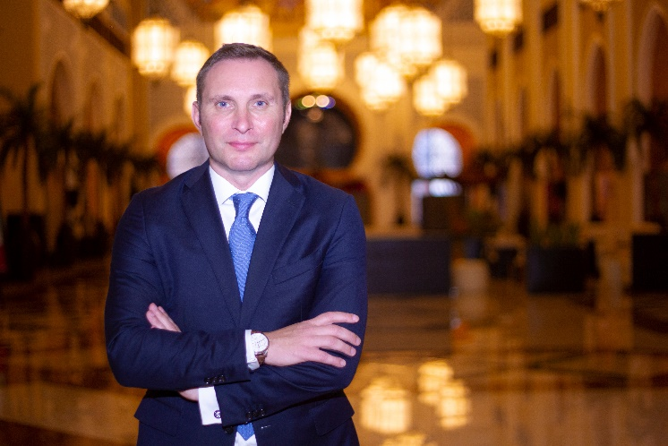
Ian Rydin represents the hotel in the 10th edition of the Great GM Debate 2019

Dubai, UAE – Mövenpick Hotel Ibn Battuta Gate placed gender balance and diversity as one of its main priorities this year. The hotel is aiming towards a strengthened representation of women holding mid-management roles which will be developed within the organization.
In a discussion about “Women in Hospitality” in the recently concluded Great GM Debate 2019 by Hotelier Middle East, Ian Rydin the General Manager of the five-star premium hotel acknowledged the lack of women leaders within the property, however, they have already taken steps in ensuring that women break through the glass ceiling, are well represented, and are given the equal chance to move up the ladder.
To further bridge the gap, Rydin set forth a pertinent KPI into increasing the representation of women in managerial positions in the hotel to 15% anchored at Accor’s goal of having 35% female hotel managers by 2020 within its network of more than 4,600 hotels through RiiSE program.
Ian said, “At Mövenpick Ibn Battuta Gate Dubai, women play a valuable role in the collective brainstorming, product enhancement, and decision making process for services and guest facing facilities.”
In the dynamic business landscape, there has been a substantial shift in the demographics which hotels now cater to. It has been observed that the products and services offered by hotels need to change and adapt to the growing number of women travellers. Diversification is key and the insights of women in the decision and product enhancement process is now indispensable.
“We ensure that women represent at least 30% of the decisive process towards the product enhancement of our Rooms, F&B offerings, and guest facing services. Their valuable insights and approach remain a crucial element in doing better business and building strengthened relationships,” added Rydin.
Diversity and inclusion
More than women representation in the workplace, Rydin reiterated that success in the hotel industry lies primarily on diversity and inclusion. These vital characteristics drive creativity and innovation, quality consumer insights, and an enhanced talent pool that eventually leads to increased business visibility and success.
“We have to understand that the end goal here is creating an environment of diversity and inclusion because each of us has a part to play in the success of the hotel.”
The hotel has already took initiatives in promoting equal opportunity such as cross-training opportunities in commercial departments and a unique employee rewards scheme geared towards growth and promotion.
“I have always been a believer of inclusion and diversity in the workplace. We have changed the employee recognition system to ensure that it sees no bias on gender, age, or race while focusing primarily on an individual’s skill sets, performance, and capabilities.”
Forging better business relationships
In recent studies, women outperform men in 11 of 12 key emotional intelligence competencies. These competencies include emotional self-awareness, empathy, conflict management, adaptability, and teamwork—all essential skills for effective leadership in the workplace.
Finally, Ian stated that, “The foundation of the hotel industry revolves on the relationships we forge between guests and staff. While research shows that men are generally results-driven, women thrive on achieving results as well as building relationships and empathetic leadership. With proper empowerment and inclusion our women of today will become the leaders of tomorrow.”

###

About Mövenpick Hotel Ibn Battuta Gate
Discover vibrant Dubai and immerse yourself in the authentic Arabian style of Mövenpick Hotel Ibn Battuta Gate Dubai. The luxury hotel is walking distance from Ibn Battuta Shopping Mall and the Dubai Metro, with easy access to Dubai’s top attractions. The Palm Jumeirah, Dubai Marina and Jebel Ali Free Zone are nearby. The 14th century travels of the Arab explorer Ibn Battuta have inspired our 396 rooms and suites, with intricate design details and cuisines from China, India, Arabia and the Mediterranean through its eight restaurants, bars and lounges. Unwind at our rooftop swimming pool, stay fit in the gym or enjoy a treatment at the spa. Take advantage of complimentary beach access and transfers to Private Beach Club on The Palm Jumeirah and get the children to explore some fun activities at the Little Birds Club. Host an unforgettable Dubai conference or event in our ballroom, 15 meeting rooms, outdoor venues or magnificent grand hall with its 88 giant lanterns.

Media contact:
Angelo De Guzman
Marketing and Communications Manager
Mövenpick Hotel Ibn Battuta Gate Dubai
Phone: +971 4 4440000 | Mobile: +971 56 9434 775 / +971 55 400 2759
angelo.deguzman@movenpick.com | www.movenpick.com

