|  |  |
| --- | --- |
| **Immediate Release** | **July 30, 2019** |

**Free Staycations and Unmissable Eid Al Adha Offers**

**Launched at Mövenpick Hotel Ibn Battuta Gate**

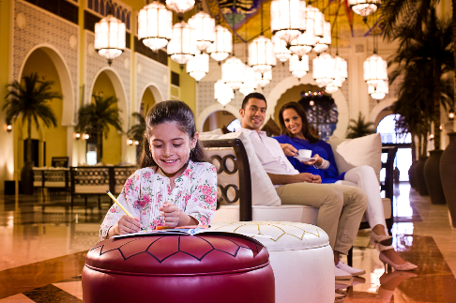

**Win a staycation, enjoy exclusive rates, and get a dining voucher during your stay**

**Dubai, UAE:** With Eid Al Adha fast approaching, Mövenpick Hotel Ibn Battuta Gate Dubai has just unveiled a fantastic holiday package to make the celebration truly memorable. Adding to the exciting offers, guests have a chance to extend their stay and win a free night when sharing their moments at the 5-star hotel by tagging them on social media (@MovenpickIBG). Book direct and get the best rates at [movenpick.com/dubai-ibn-battuta](http://www.movenpick.com/dubai-ibn-battuta)

“Eid Al Adha is the perfect opportunity to enjoy a well-deserved break with your loved ones. The holidays give way for both UAE and GCC guests to enjoy their staycation while staying close to shopping, theme parks, beaches, and entertainment. Known for its iconic Middle Eastern architecture the hotel has paired luxury accommodation and dining offers together, which are curated to suit families that are staying or travelling to Dubai during the holidays,” said Ian Rydin, General Manager, Mövenpick Hotel Ibn Battuta Gate Dubai.

**Dubai Eid Staycation Offer for UAE and GCC Residents**

* Book through: <http://bit.ly/eidoffermibg> or use promo code: GCCUAERES17
* Rates starting from AED 245 per room per night.
* Complimentary dining voucher valued at AED 70 per room per stay.
* Exclusive access and daily service to the private beach at The Palm.
* Valid GCC and/or UAE ID is required upon check in.
* Rate is subject to 5% VAT, 10% service charge, 7% municipality fees, and AED 20 Tourism Dirham Fee per bedroom, per night.

**Rewarding Moments: Get a chance to Win a Free Staycation**

Share your moments on social media when staying or dining at Mövenpick Hotel Ibn Battuta Gate for a chance to win a free night stay.

* Tag @MovenpickIBG and use #MovenpickIBG and #Approve to participate.
* Page posts only. Stories are not counted.
* Winners will be messaged directly and is chosen at random.
* Free night stays can be redeemed within 30 days from the date of winning.

For reservations and more information, contact: 04 444 0000 / [reservations.ibnbattuta@movenpick.com](mailto:reservations.ibnbattuta@movenpick.com)

*---ends---*

**About Mövenpick Hotel Ibn Battuta Gate**

Discover vibrant Dubai and immerse yourself in the authentic Arabian style of Mövenpick Hotel Ibn Battuta Gate Dubai. The luxury hotel is walking distance from Ibn Battuta Shopping Mall and the Dubai Metro, with easy access to Dubai’s top attractions. The Palm Jumeirah, Dubai Marina and Jebel Ali Free Zone are nearby. The 14th century travels of the Arab explorer Ibn Battuta have inspired our 396 rooms and suites, with intricate design details and cuisines from China, India, Arabia and the Mediterranean through its eight restaurants, bars and lounges. Unwind at our rooftop swimming pool, stay fit in the gym or enjoy a treatment at the spa. Take advantage of complimentary beach access and transfers to Private Beach Club on The Palm Jumeirah and get the children to explore some fun activities at the Little Birds Club. Host an unforgettable Dubai conference or event in our ballroom, 15 meeting rooms, outdoor venues or magnificent grand hall with its 88 giant lanterns.

**Media contact:**

Angelo De Guzman

Marketing and Communications Manager

Mövenpick Hotel Ibn Battuta Gate Dubai

Phone: +971 4 4440000 | Mobile: +971 56 9434 775 / +971 55 400 2759

angelo.deguzman@movenpick.com | www.movenpick.com