News Release – May 23, 2019

Mövenpick Hotel Ibn Battuta Gate named as one of the Best Hotels in Middle East for 2019

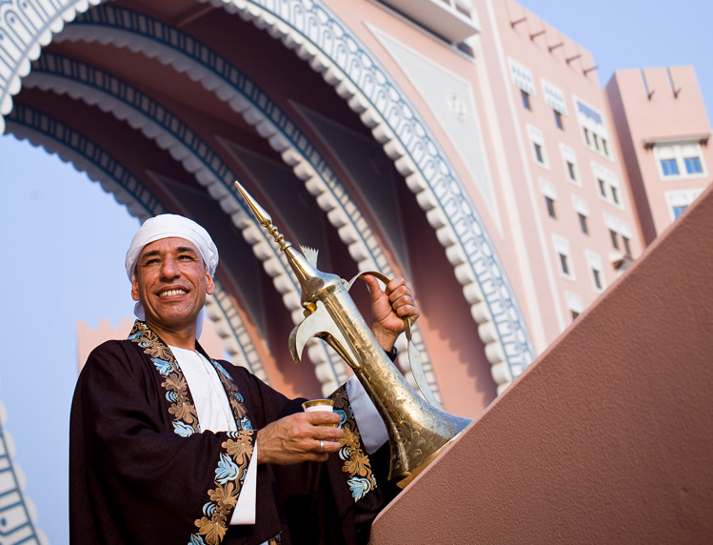

The hotel was handpicked for its service standards, culinary and leisure offerings, and stellar architecture from thousands of hotels in the region.
Dubai, UAE – Mövenpick Hotel Ibn Battuta made it into the prestigious list of Top 50 Hotels in the Middle East, standing out as one of Arabia’s finest properties across the Gulf region.

The list, expertly curated by Hotelier Middle East, handpicked the iconic five-star hotel through a rigorous process based on the hotel’s reputation – both online and offline, guest reviews, interior design, and inputs from editors and industry experts.

“We are proud of this achievement and our people that work tirelessly to make our guests feel welcome at Mövenpick Hotel Ibn Battuta Gate Dubai. This prominent recognition in the region is a reflection of the hard work and dedication our team puts in to make every moment memorable,” said Ian Rydin, General Manager, Mövenpick Hotel Ibn Battuta Gate Dubai.

Following Rydin’s recent appointment, he elaborates that the team’s continued focus on a guest-centric approach, improved services, and a healthy working environment is key to their success.

An iconic landmark that links Dubai and Abu Dhabi, the five-star hotel’s awe-inspiring Arabian architecture is highlighted by the grand hall, Al Bahou boasting a picturesque view of 88 Moroccan lanterns. It has 396 rooms and suites and 15 meeting rooms that are patterned from the travels of the Arabic explorer Ibn Battuta to the Middle East, Asia, India, and Italy alongside the hotels eight signature restaurants, bars and lounge.

Know more at: @MovenpickIBG | movenpick.com/dubai-ibn-battuta

# # #

About Mövenpick Hotel Ibn Battuta Gate
Discover vibrant Dubai and immerse yourself in the authentic Arabian style of Mövenpick Hotel Ibn Battuta Gate Dubai. The luxury hotel is walking distance from Ibn Battuta Shopping Mall and the Dubai Metro, with easy access to Dubai’s top attractions. The Palm Jumeirah, Dubai Marina and Jebel Ali Free Zone are nearby. The 14th century travels of the Arab explorer Ibn Battuta have inspired our 396 rooms and suites, with intricate design details and cuisines from China, India, Arabia and the Mediterranean through its eight restaurants, bars and lounges. Unwind at our rooftop swimming pool, stay fit in the gym or enjoy a treatment at the spa. Take advantage of complimentary beach access and transfers to Private Beach Club on The Palm Jumeirah and get the children to explore some fun activities at the Little Birds Club. Host an unforgettable Dubai conference or event in our ballroom, 15 meeting rooms, outdoor venues or magnificent grand hall with its 88 giant lanterns.

movenpick.com | accorhotels.com

For further information, please contact:
Angelo De Guzman
Marketing and Communications Manager
Mövenpick Hotel Ibn Battuta Gate Dubai
Phone: +971 4 4440000 | Mobile: +971 56 9434 775 / +971 55 400 2759
angelo.deguzman@movenpick.com | www.movenpick.com

