PRESS RELEASE
RedGuard Specialist Services

FOR IMMEDIATE RELEASE Dubai, 14th November 2018

RedGuard Specialist Services signs Agency Agreement with EQIN in Rotterdam

Dubai, 19th November 2018 – RedGuard Specialist Services has announced a new Agency Agreement with EQIN, the leading specialist in equipment solutions, to provide blast-resistant modular buildings in Europe.
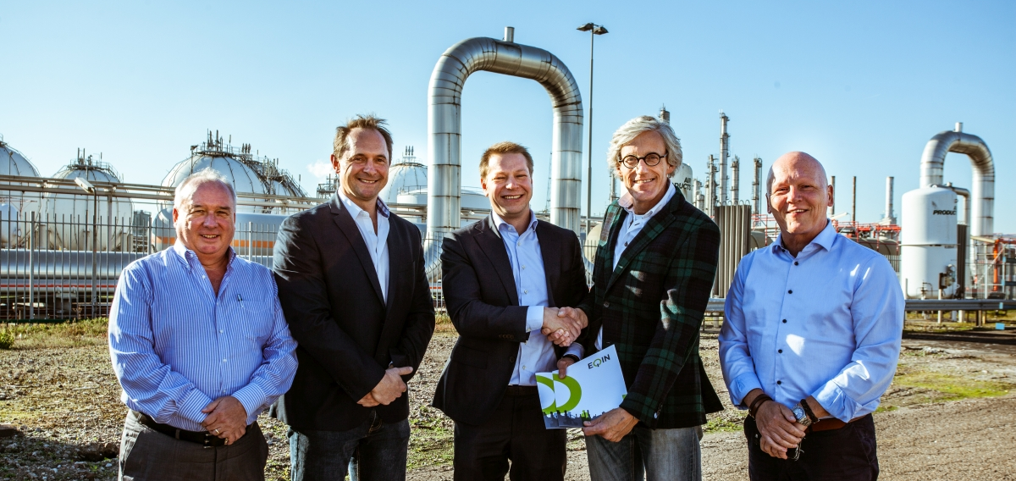

In the photo (from left to right): John Kay, General Manager (RedGuard Specialist Services), Chris Ridley, Director (RedGuard Specialist Services), Rogier van Riet, Business Development Manager – Europe (RedGuard Specialist Services), Arjan Simmelink, Technical Director (EQIN), and Paul Verloop, Regional Manager South West (EQIN).

This partnership with EQIN will allow RedGuard Specialist Services to further penetrate the European market for blast-resistant modular buildings for sale and hire. Being the leading specialist in equipment solutions with business locations in the Netherlands, Belgium and Germany, EQIN is well established and perfectly positioned to supply RedGuard Specialist Services’ blast-resistant modular buildings in North-West Europe.

– MORE – Page 1 of 2

Arjan Simmelink, Technical Director at EQIN said: “We are very excited about the agreement with RedGuard Specialist Services and are looking forward to doing business together. These modules are a valuable expansion of the equipment we can offer our customers at petrochemical plants who have to work in explosion-sensitive zones”.

With Headquarters in Rotterdam, the Netherlands, EQIN is the most versatile all-round player in the field of industrial equipment rental and sales, and is a 100% subsidiary of Stork, a Fluor company. EQIN sells and rents temporary energy, air, lighting and welding installations, tools and equipment and accessories in the chemicals, oil and gas, power, steel and shipbuilding market segments. The provision of total concepts is one of EQIN’s strengths. Throughout the world, they supply total concepts on a project basis consisting of tools and equipment, staff, safety inspections, budget management and complete site facilities for turnarounds and new constructions.

Editor’s notes

RedGuard Specialist Services

RedGuard Specialist Services is a Dubai based RedGuard and Specialist Services Joint Venture Company. Specialised in the design, engineering and manufacturing of blast-resistant and ballistic-resistant modular buildings, we have strategically positioned distribution centres in UAE, KSA, Singapore, UK, The Netherlands and USA to address the needs of our customers worldwide. Our blast-resistant modules are specifically designed to maximize safety, apply a proven, successfully blast tested design and are fully compliant with international industry standards.

For more information you can visit the corporate website at www.redguard.specserve.com or contact:

Natasa Kobal, Marketing & Communications Manager
Tel: +971 4 816 4500
Mob: +971 50 204 5362
Fax: +971 4 816 4501
Email: natasa@specserve.com

